**Department of Information Technology**

**Academic Year: 2022-23 Name of Student:**

**Semester: VI Student ID:**

**Class / Branch / Div: TE- IT A/B Roll No.**

**Subject: MAD & PWA Lab Date of Submission:**

**Name of Instructor:**

**Experiment No.:11**

**Aim:** Make use of google Lighthouse PWA Analysis Tool to test the PWA functioning.

**Prerequisites:** HTML, JavaScript, JSON**.**

**Software:** VS code, Browser, Lighthouse tool**.**

**Problem Statement:** Make use of google Lighthouse PWA Analysis Tool to test the PWA functioning of web application created in experiment:8

**Code:**

### Run Lighthouse in Chrome DevTools

Lighthouse powers the **Audits** panel of Chrome DevTools. To run a report:

1. Download [Google Chrome for Desktop](https://www.google.com/chrome/browser/desktop/).
2. In Google Chrome, go to the URL you want to audit. You can audit any URL on the web.
3. [Open Chrome DevTools](https://developers.google.com/web/tools/chrome-devtools#open).
4. Click the **Audits** tab.
5. Click **Perform an audit**. DevTools shows you a list of audit categories. Leave them all enabled.
6. Click **Run audit**. After 30 to 60 seconds, Lighthouse gives you a report on the page.

**Output:**

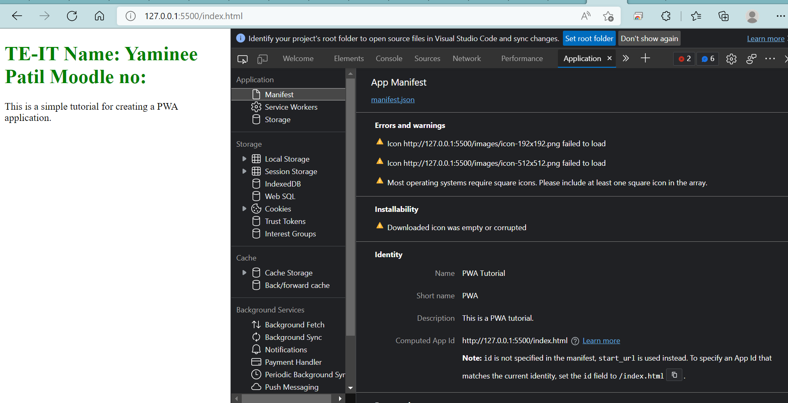

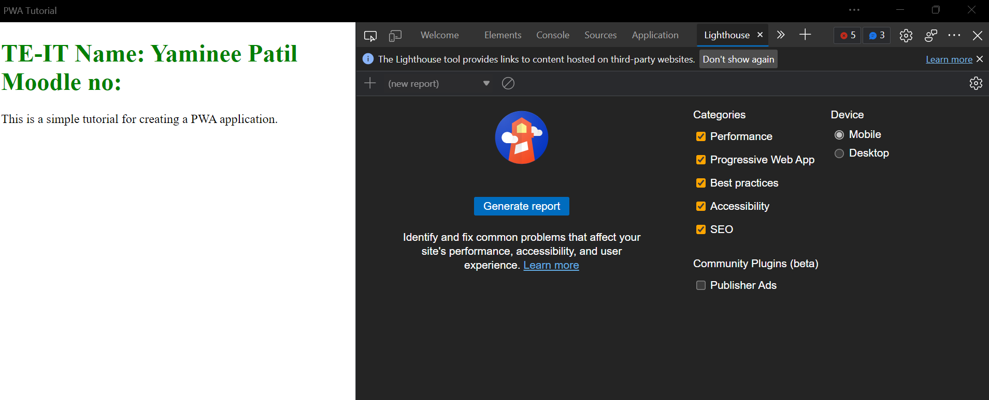

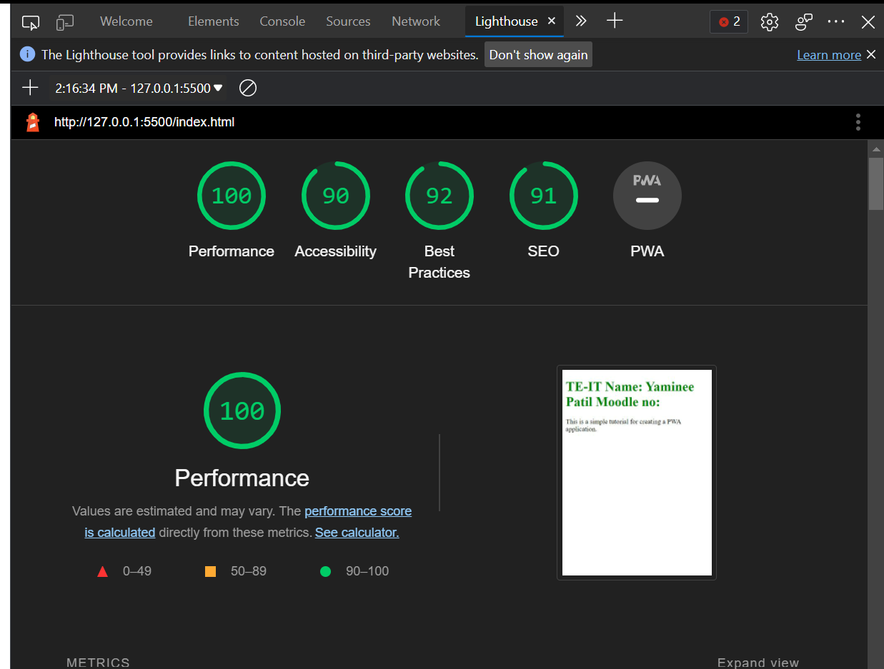

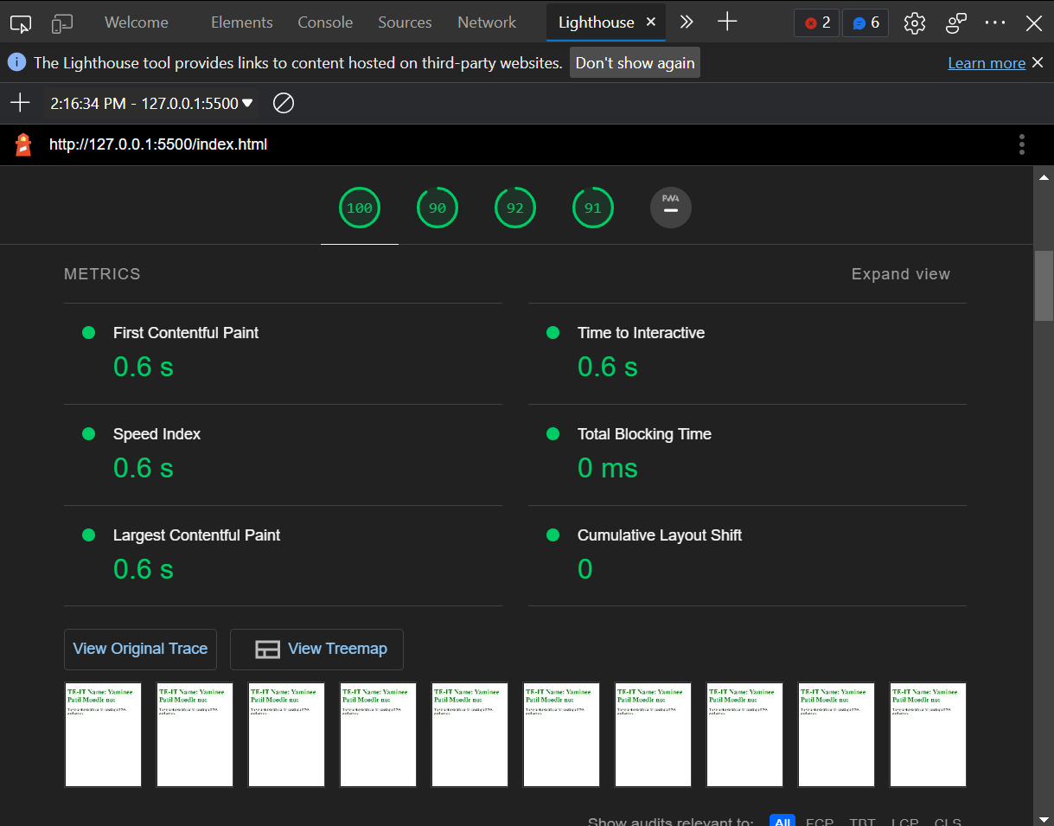

**Conclusion:** In this experiment we have use of google Lighthouse PWA Analysis Tool to test the PWA functioning and report analysis.